TOMORROWS LEADERS TODAY
2020
Ben Oxley | Text him at: 770545-9544
 | Bio: Ben is a young adult who believes in pushing himself beyond existing limits and not letting any disability stop him. He challenges himself to master new activities. Skydiving has become one of his favorite activities, and his third jump has been scheduled.
 | CAP: Ben’s Action Plan will be to create videos of him skydiving and living an active unrestricted life. He will interview other individuals who have disabilities to discuss how they are living fulfilled, productive lives. He intends to blog about his life’s story and other individuals’ stories. His Action Plan will also include starting a business that sells casual clothing.
Hannah Hibben | Text or email: 770-262-7021, dhibben@bellsouth.net (Mom: Debbie)
 | Bio: Hannah is a young adult who has 3 part time jobs. Two of the jobs are food service focused (a cookie shop for 4 years and a yogurt shop for 2 years) and one job is recycling computer hardware equipment (less than 1 year). These work experiences have strengthened Hannah’s self-confidence and have helped her to develop and practice self-advocacy skills.
 | CAP: Hannah’s Action Plan will be to video and interview the approximately 20 individuals on her Special Olympics tennis team. The videos of her teammates practicing/playing tennis will perhaps empower those viewers who have disabilities to stretch beyond their current limits. One of the skills that this Action Plan might help Hannah gain could be expand her communication skills.
Ryan Lee | Text or email: 404-452-1917, ryanalee@bellsouth.net
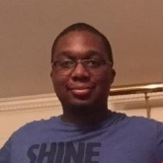 | Bio: Ryan is an outgoing young man who is on the (autism) spectrum and is energized by increasing/improving his self-advocacy skills. He enjoys hanging out with his friends and meeting new people. He likes dogs and has a corgi.
 | CAP: He wants his Community Action Plan to include doing various activities like bowling. However, the uncertainty caused by the coronavirus pandemic has been stressful for him. It has made it too difficult for him to focus on what else he wants in his Action Plan.
Otis Maffett | Text or call: 229-225-6952 (Mom: Kay)
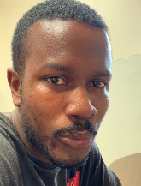 | Bio: Otis describes himself as an artist. Creating artwork, writing poetry, and playing basketball are activities that give Otis a lot of personal satisfaction. These activities have helped him to develop his self-advocacy voice.
 | CAP: Otis intends to use his Action Plan to help him improve/advance his skills as an artist. The content of the artwork will focus on cartoon-like graphics, representations of cars and shoes, and designing different items of clothing.
Kyleigh Kramlich | Text or email: 770-713-8949, Kyleigh.kramlich@hebronlions.org
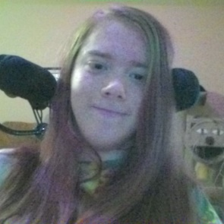 | Bio: My name is Kyleigh. I live in Lawrenceville. My birthday is June 8th, 2002. I am 18 years old. I’m in the eleventh grade at Hebron Christian Academy. I am runner. My favorite race is the Publix half-marathon, but I have run in over 30 races, including 5Ks, 10Ks, half marathons and full marathons.
 | CAP: Kylegh’s Community Action Plan is BIG! She is the race coordinator for One Voice Georgia – a virtual run, walk, roll or bike. She is working in collaborating with local chapters of The Arc Georgia Network to facilitate a road race to bring together people with disabilities, their families, providers, and advocates from across the state to run with a unified voice in support of disability rights for all. “Running is like flying - come fly with us!”

